**Initial framing and deviation**

From the initial framing of the problem to report out a food complaint, the analysis is modified to determine if the complaint received qualifies for a recall and what category of recall does the reason for re-call fall into.

**Why the question is important** :  Primarily the Food Manufacturing industry takes significant time and resources to determine whether the complaint classifies as a recall and what kind of class it belongs, to determine the urgency of the recall process. One of the plots from de codetermines the lag in number of days since a complaint was filed and a classification was determined because of the heavily human interfered process. The ML initiative is to create a model to identify if the event/complaint qualifies for a recall and which class of recall it belongs to.

 Recalls are actions taken by a firm to remove a product from the market. Recalls may be conducted on a firm's own initiative, by FDA request, or by FDA order under statutory authority.

Class I recall: a situation in which there is a reasonable probability that the use of or exposure to a violative product will cause serious adverse health consequences or death.

Class II recall: a situation in which use of or exposure to a violative product may cause temporary or medically reversible adverse health consequences or where the probability of serious adverse health consequences is remote.

Class III recall: a situation in which use of or exposure to a violative product is not likely to cause adverse health consequences.

**Dataset** **and Initial analysis**

The dataset used for generating the model is directly downloaded files in JSON format from the FDA complaints and recalls database. The focus was primarily on the reason for recall field, where some of the key words for recall for grouped to evaluate the type of recalls at large. But mostly this would be a classical NLP based multi-classification model. And for that reason, Naïve Bayes model was chosen as the base line model.

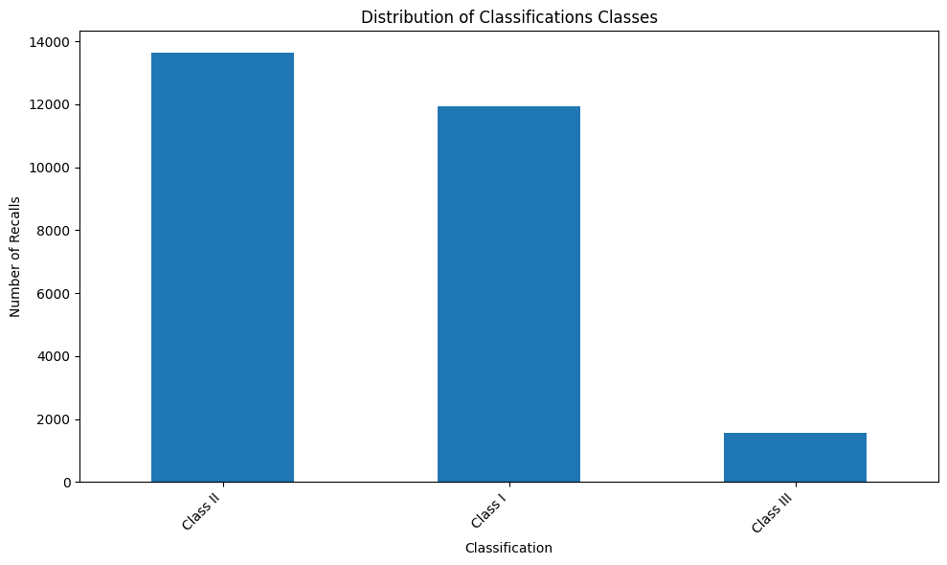

**Baseline Model output – Naïve Bayes**

Accuracy: 0.815033161385409

precision recall f1-score support

Class I 0.86 0.82 0.83 2401

Class II 0.78 0.88 0.83 2718

Class III 0.86 0.23 0.36 309

accuracy 0.82 5428

macro avg 0.83 0.64 0.67 5428

weighted avg 0.82 0.82 0.81 5428

After the initial evaluation of the base line model which showed a decent accuracy, we used multiple regression and classification models, focused just on the column ‘reason for recall’ as the only feature for NLP modeling.

**Logistic Regression**

Accuracy: 0.8848563006632277

Best Parameters for Logistic Regression: {'C': 10}

precision recall f1-score support

Class I 0.88 0.90 0.89 2401

Class II 0.89 0.89 0.89 2718

Class III 0.86 0.71 0.78 309

accuracy 0.88 5428

macro avg 0.88 0.83 0.85 5428

weighted avg 0.88 0.88 0.88 5428

**Random Forest**

Accuracy: 0.909174649963154

Best Parameters for Random Forest: {'max_depth': None, 'n_estimators': 100}

precision recall f1-score support

Class I 0.92 0.92 0.92 2401

Class II 0.90 0.93 0.91 2718

Class III 0.94 0.67 0.78 309

accuracy 0.91 5428

macro avg 0.92 0.84 0.87 5428

weighted avg 0.91 0.91 0.91 5428

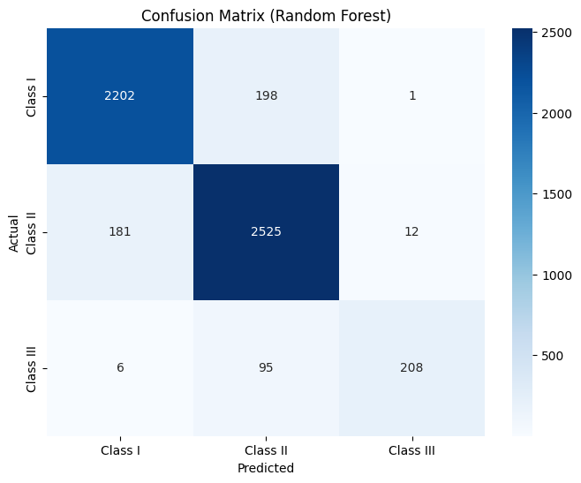

**Support Vector Machine**

Accuracy: 0.9119380987472365

Best Parameters for SVM: {'C': 10, 'kernel': 'rbf'}

precision recall f1-score support

Class I 0.92 0.93 0.92 2401

Class II 0.91 0.92 0.91 2718

Class III 0.92 0.71 0.80 309

accuracy 0.91 5428

macro avg 0.91 0.85 0.88 5428

weighted avg 0.91 0.91 0.91 5428

|  | **Model** | **Accuracy** |
| --- | --- | --- |
| **0** | **Naive Bayes** | **0.833456** |
| **1** | **Logistic Regression** | **0.884856** |
| **2** | **Random Forest** | **0.909175** |
| **3** | **SVM** | **0.911938** |

**Evaluation Metrics Interpretation**

The two evaluation metrices: accuracy and the classification report (which includes precision, recall, F1-score, and support).

For each class, precision is the proportion of correctly predicted positive observations to the total predicted positive observations.  A high precision means that when the model predicts a class, it is likely to be correct.

For each class, recall is the proportion of correctly predicted positive observations to the all observations in actual class. A high recall means that the model is good at identifying all positive instances of a given class. The F1-score is the harmonic mean of precision and recall.  It provides a balanced measure that considers both false positives and false negatives.  It's particularly useful when the classes are imbalanced.

While accuracy gives an overall picture, the classification report provides a more granular analysis of the model's performance for each class. This is crucial because the classes might be imbalanced (different numbers of Class I, II, and III recalls).  Accuracy alone could be misleading if one class significantly outnumbers others.  The classification report helps identify if the model is performing well for all classes or if it's biased towards certain classes, particularly important for recall which is how well it finds all of a specific class of recalls.  In this food recall context, correctly identifying all Class I recalls (most serious) is critical even if the model makes a few more errors on less severe recalls. A low recall and F1 Score for Class III due to lesser data.

After evaluating all the models, Support Vector Model is having an higher accuracy and precision across all classifications, closely followed by Random Forest. Boosting Random Forest model did not help as the accuracy reduced drastically. Boosting SVM was costing high GPU usage and was not able produce any outputs with the existing GPU capacity. (Code is provided for the same). Final recommendation is to rely on SVM with the below mentioned accuracy and parameters.

Accuracy: 0.9119380987472365

Best Parameters for SVM: {'C': 10, 'kernel': 'rbf'}